# Subsetting Rows - Individuals Greater Than 10,000

This document includes the question, the solution, and a breakdown of the code provided in the screenshot.

## Uploaded Screenshot

Below is the screenshot of the task:

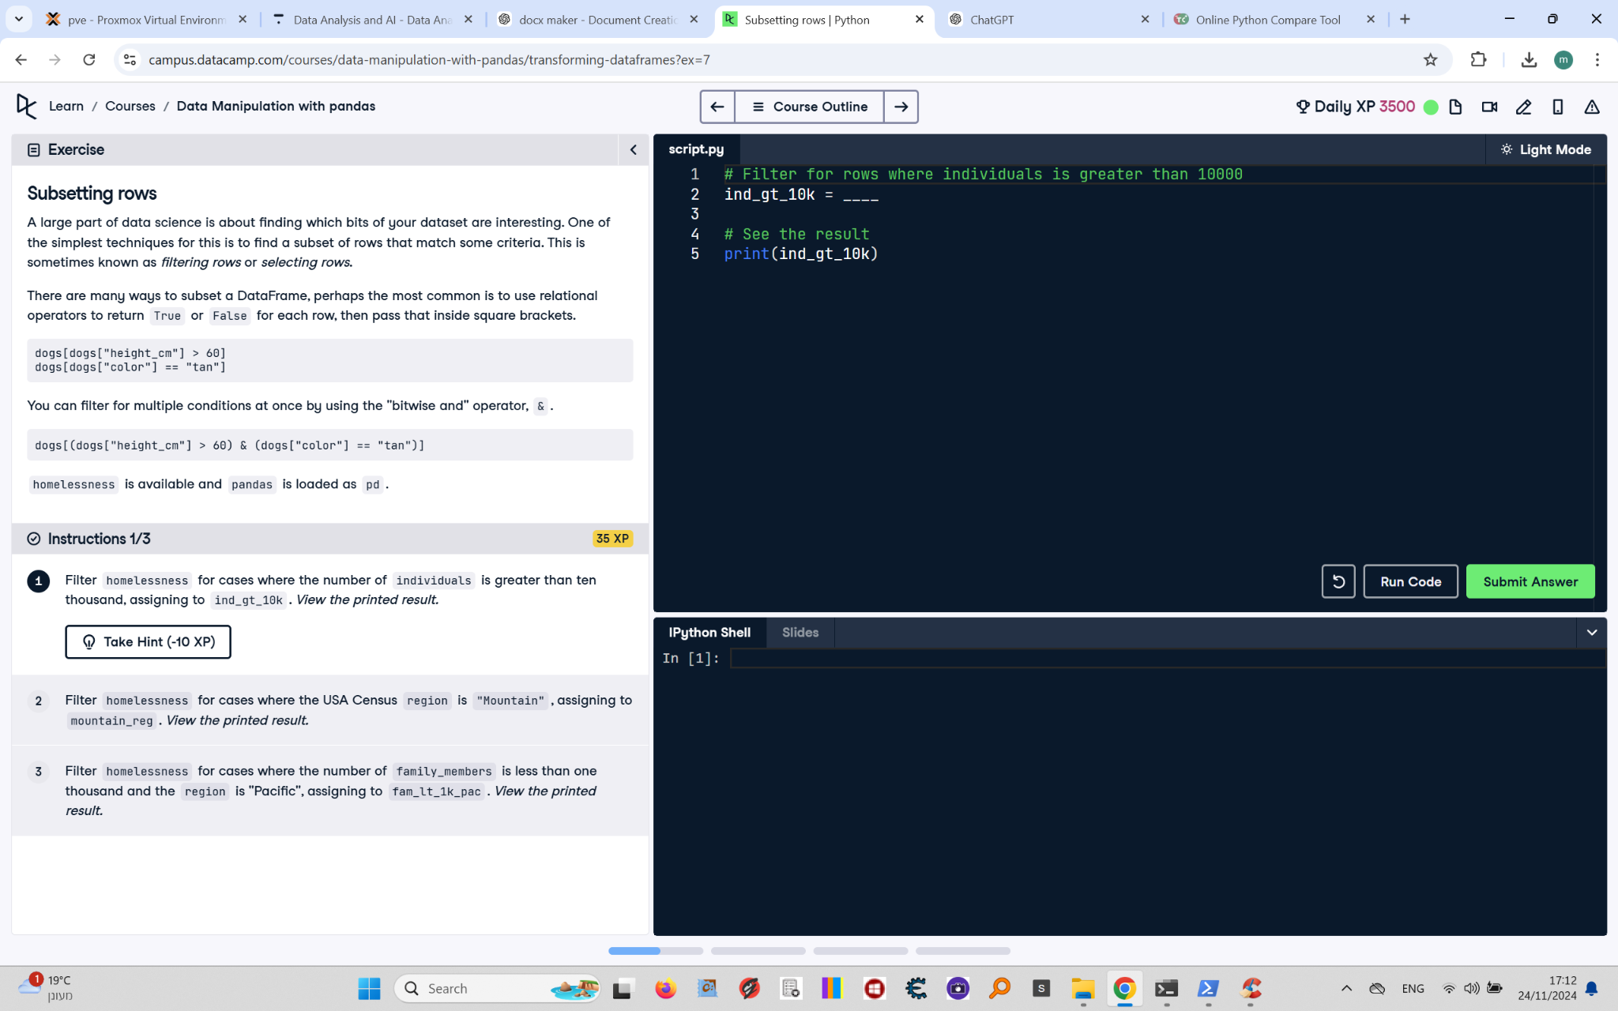

## Question

Filter `homelessness` for cases where the number of `individuals` is greater than ten thousand, assigning the result to `ind_gt_10k`. View the printed result.

## Answer

# Filter for rows where individuals is greater than 10000  
ind_gt_10k = homelessness[homelessness["individuals"] > 10000]  
  
# See the result  
print(ind_gt_10k)

## Code Explanation

# Explanation of the code:

1. `homelessness["individuals"] > 10000`: This creates a boolean mask, where each row evaluates to `True` if the value in the `individuals` column is greater than 10,000, and `False` otherwise.

2. `homelessness[homelessness["individuals"] > 10000]`: Filters the `homelessness` DataFrame by keeping only rows where the mask is `True`.

3. `ind_gt_10k`: Stores the filtered DataFrame for further use.

4. `print(ind_gt_10k)`: Prints the resulting DataFrame to verify the filter.